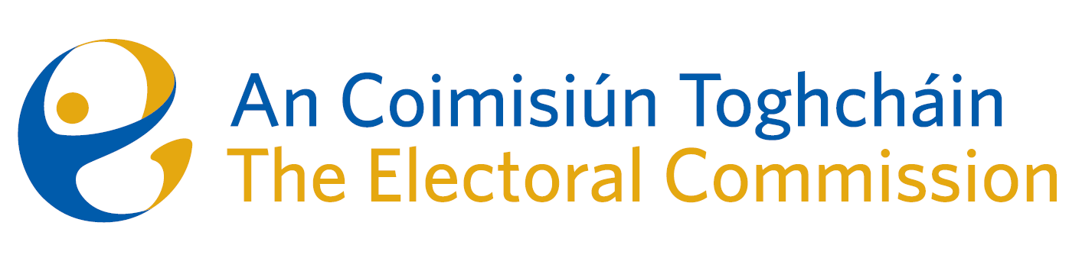

**Customer Services Charter**

1. **Introduction**

An Coimisiún Toghcháin is a statutory, independent body, established on 9 February 2023 with responsibility for a broad range of electoral functions set out in the Electoral Reform Act 2022. An Coimisiún is central to Ireland’s electoral system, carrying out a range of existing electoral functions, including:

* the conducting of reviews and making reports in relation to the constituencies for the election of members to the Dáil and the election of members to the European Parliament;
* responsibility for the registration of political parties;
* the decision-making, oversight, secretariat and supporting services associated with explaining the subject matter of referendum proposals, the promotion of public awareness of referendums and encouragement of the electorate to vote at referendum polls; and
* making reports for the Minister in relation to local electoral boundaries.

An Coimisiún is also tasked with several new electoral roles, including:

* preparing research programmes and conducting research on electoral policy and procedure, and providing advice, as required, to the Minister and Government;
* promoting public awareness of, and working to increase public participation in the State’s electoral and democratic processes through education and information programmes;
* overseeing the modernised Electoral Register, making recommendations and setting standards in relation to its maintenance and updating;
* the regulation of online paid-for political advertising, ensuring transparency in respect of online political advertisements during the period of an election or referendum campaign;
* responsibility for the investigation and monitoring of online disinformation, online misinformation and manipulative or inauthentic behaviour online during election campaign periods, as well as functions to prevent manipulative or inauthentic behaviours online (Legislation not yet commenced); and
* the preparation of ex-post reports on the administration of electoral events.

It is anticipated that the initial set of functions assigned to An Coimisiún will be expanded upon as it builds capacity and expertise.

1. **What to expect when you contact us**

When you engage with An Coimisiún Toghcháin we will:

* Greet you politely and engage with you with courtesy, dignity and respect;
* Direct you to the person or organisation that you need or who is best placed to assist with your query promptly;
* Listen and provide a prompt and comprehensive response should you have a query;
* Protect your personal information in line with all Data Protection requirements; and
* Ensure that the information provided on our website is up to date, accessible and provided in a timely manner.

1. **Contact by telephone**

When you contact us by telephone you can expect that we will:

* Answer your calls during office hours from 9:00am-5:00pm, Monday to Friday;
* Facilitate you by allowing you to record a voicemail message where phones are unattended and update voicemail messages as appropriate to indicate staff availability;
* Respond to your voicemail messages within one working day of receipt;
* Deal with your query in a courteous, respectful and helpful manner;
* If we cannot do so immediately, we will take your details and call you back as soon as possible; and
* If the information you wish to convey by phone is complex or lengthy you may be asked to communicate that information to us in writing.

1. **Contact us by Letter, Email or Online Enquiry**

When you contact us in writing, by letter or email, we commit to:

* By email - we will issue an automated response confirming receipt of your email and a commitment to respond as below:
* The email will be referred to the relevant team;
* Acknowledge or reply by the relevant team to your written communication within three working days;
* After an acknowledgement, reply more substantively if required to your enquiry within 20 working days;
* In cases where we cannot provide a full reply within this period, provide you with an interim reply explaining why and indicate when you can expect a full reply;
* Write to you in clear language and avoid using technical terms; and
* Explain to you when the matter raised is not within our remit and, where possible, provide you with contact details for a more appropriate alternative organisation.

1. **Redirecting Communications which do not relate to An Coimisiún**

If you contact us about a matter which does not fall within our remit, we will:

* Indicate that we do not have a role in the particular matter;
* Explain our functions to you; and,
* Make every reasonable effort to identify the organisation which will be in a position to deal with the matter.

1. **Unreasonable Communication**

*Written correspondence*

We will not accept correspondence that is abusive or threatening to staff. We will not respond to any correspondence containing such language.

*Telephone calls*

We will tell the person if we think their language during telephone calls is inappropriate, abusive or offensive and ask them to stop using such language. Staff have the right to terminate the telephone call if the behaviour continues.

1. **Complaints procedure**

If you are not satisfied with how you were dealt with by our staff, you can make a complaint by.

Email: [info@electoralcommission.ie](mailto:info@electoralcommission.ie)

Phone: +353 (1) 539 1040

Post: Address: An Coimisiún Toghcháin, Dublin Castle, Dublin 2, D02 X8X8

On receipt of a complaint, we will:

* Refer the complaint to the most relevant staff member;
* Respond to the person who complained as outlined on page 3 of this document; and
* Refer the matter to our Corporate Services team, if the person who complained is not satisfied with our response.

1. **Service through Irish**

We will make every effort to assist you if you wish to conduct your business with us through the Irish language.

Email: [eolas@electoralcommission.ie](mailto:eolas@electoralcommission.ie)

Telephone: +353 (1) 539 1062 / +353 (1) 539 1040

This includes the following commitments:

* Correspondence received in Irish will be answered in Irish;
* We will ensure that if a member of the public wishes to conduct their business through Irish by telephone that an official of An Coimisiún will be available to provide such a service when required.
* We will publish key documents including our Annual Reports in Irish and English;
* An Irish version of our website will mirror as far as practicable the English version; and
* We will meet our other commitments under the Official Languages Act.

1. **Equality and Diversity**

In developing this Customer Service Charter, An Coimisiún has had regard to the considerations regarding eliminating discrimination, promoting equality and protecting human rights identified in section 42 (1)(a) (c) of the Irish Human Rights and Equality Commission Act 2014;

1. **Contact Details**

Email: [info@electoralcommission.ie](mailto:info@electoralcommission.ie)

Phone: +353 (1) 539 1040

Address: An Coimisiún Toghcháin, Dublin Castle, Dublin 2, D02 X8X8

Website: <https://www.electoralcommission.ie/contact-us/>

1. **Policy review**

The policy will be reviewed at minimum intervals of three years or when required by the An Coimisiun’s Management Team.